
  BISS Bakeries Uganda
  195 volgers

In het hart van Kikajjo-Kyengera, in het district Wakiso, Oeganda, leeft een verhaal van veerkracht… meer weergeven
 |  |  | 37 | · | 1 commentaar

Meer informatie

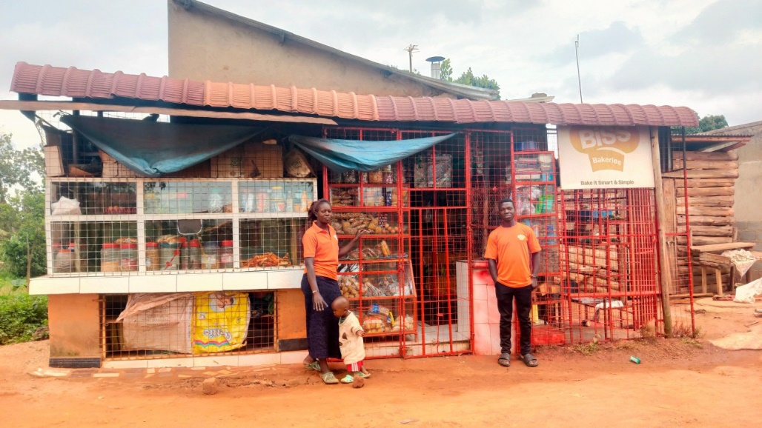
From Caretaker to Entrepreneur: Lukia’s Inspiring Journey with BISS

From Caretaker to Entrepreneur: Lukia’s Inspiring Journey with BISS

BISS Bakeries Uganda

196 volgers
6 november 2024
In the heart of Kikajjo-Kyengera, Wakiso District, Uganda, lives a story of resilience, transformation, and empowerment. Namatovu Lukia, a 40-year-old mother of five, never imagined the turn her life would take when she joined BISS Bakeries (Bake It Smart and Simple) in 2021. Her journey from being a caretaker for her Mentally ill brother, Kyagulanyi Shaban, to a successful entrepreneur has been remarkable.
A Humble Beginning
Lukia first became involved with BISS through her late brother, Kyagulanyi Shaban, who was a direct beneficiary of the program. As his caretaker, Lukia ran a BISS phase 1 bakery to support him. After attending a two-week on-location training with BISS in Kikajjo-Wakiso, Lukia mastered the basics of deep-frying products like chapati, samosa, donuts among others. She received her startup kit in May 2021, and with hard work and dedication, she was soon running a thriving small bakery. However, her own life changed in ways she never anticipated. While navigating this difficult period, she quickly discovered a passion for baking and started the pursuit for phase 2. By August 2023, she had cleared her startup loan and was ready to advance to Phase 2 of the program.
Growth Through BISS Training
Phase 2 was a turning point for Lukia. Supported by EFMI Business School and Bake for Life College, she gained advanced skills in baking oven-based products such as cakes, bread, cookies, scones and many more. The training not only enhanced her technical skills but also empowered her with the business acumen and confidence to scale her bakery. Her products quickly became popular within her community, and as her business flourished, so did her economic stability.
Lukia’s business success enabled her to make meaningful contributions to her family’s well being. Alongside her husband, she expanded their land, and they began construction on their dream home—a beautiful flat symbolizing her achievements and resilience.
A Heartfelt Appreciation
Reflecting on her journey, Lukia shared, “BISS, together with my sponsors, have transformed my life in ways I never thought possible. From being a caretaker and shop attendant to becoming a successful entrepreneur, I’ve discovered a new sense of purpose. The training, support, and guidance I received have been invaluable.”
Her bakery is now a cornerstone of her community, not only bringing joy through delicious treats but also creating employment and inspiring others. Lukia’s journey is a testament to the impact of BISS in empowering individuals to break free from limitations and pursue their dreams.
Looking Ahead
Today, Lukia is a proud entrepreneur, deeply grateful for the opportunities BISS and its partners have provided. Her story is one of hope and transformation, demonstrating that with the right support, anyone can achieve their dreams.
Let Lukia’s journey inspire us all to believe in the power of resilience, community, and empowerment.
#bakingForInclusivity #BakingWithPurpose #YouthInBaking #bakeForLife #BakingEntrepreneurs #Bbrood #LearnWithBISSBakeries
Dit artikel rapporteren

